﻿Pennsylvania State Criminal History Record Instructional Screenshots

- PA State Police Website:
http://www.psp.pa.gov/Pages/Request-a-Criminal-History-Record.aspx

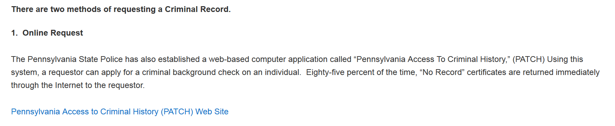
- Scroll down to section 1. Online Request and click on the link marked Pennsylvania Access to Criminal History (PATCH) Web Site.

- Scroll down to the Credit Card Users section and click on Submit a New Record Check.
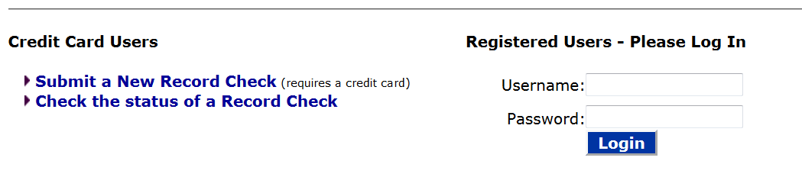

- At the bottom of the page, Accept the Terms and Conditions.

- Reason for Request: Employment; Volunteer = $0 charge once every 5 years.
- Enter your personal information: first name, last name, address, country, phone number.
- Click Next.
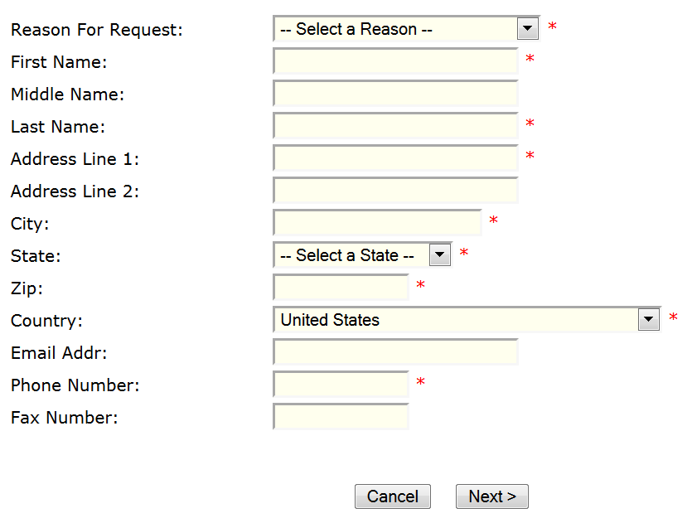

- On the Personal Information Review screen, click Proceed.

- On the Record Check Request Form screen, enter your personal information: name, social security #, date of birth, sex, race, aliases and/or maiden name.
- Click on Enter This Request

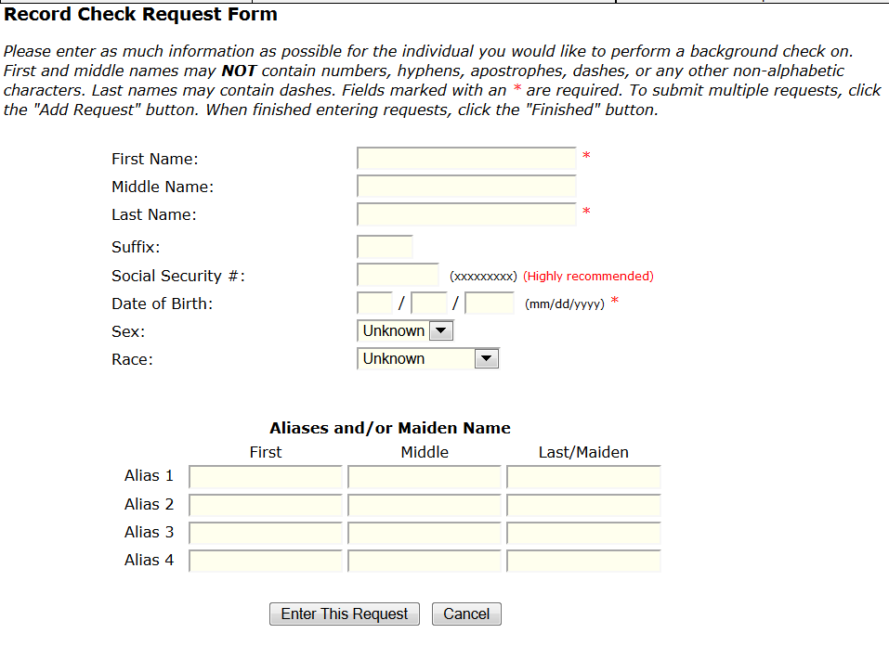

- Click on Finished for one request.

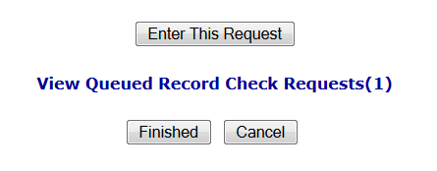

- A Request Queue screen will appear. Click on Submit.

- Enter your personal credit card information and click Next. This is an old screenshot – you will only be charged $8 under the current laws. If you completed this for “Volunteer” purposes, there will be no charge (once every 5 years).

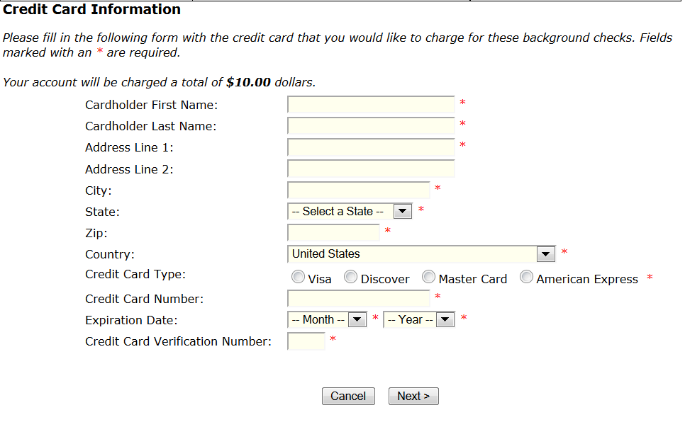

- Click Submit.

- On the Record Check Request Results screen, write down your Control Number for future reference (if you need to check the status of a report).
- Click on the Control Number hyperlink to view the details of the report.
- Click on Certificate Form hyperlink.

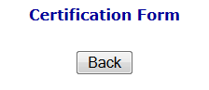

- Save the certificate. Click on the word ‘Save” in the top right corner. If you cannot save it as a PDF file, please Print the certificate.
Note: once viewed, you will have no further access to the document.

- Scan the document as a PDF. The PDF version obtained directly from the epatch website it encrypted. It needs to be printed and scanned to remove the encryption. Another option is to ‘print’ or ‘convert’ the saved PDF to a new PDF.

- Upload the un-encrypted PDF certificate to your CastleBranch account.

