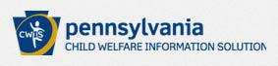

Pennsylvania Child Abuse Clearance

Summary of Steps

• Order LE48abuse from Castle Branch; then follow link

• Register & Create Account
• Change Temporary Password
• Log into Child Welfare Portal (CWP)
• Complete Child Abuse Clearance Application

As a registered user on the CWP you can:
• Submit the On‐Line Child Abuse Clearance Application
• Check clearance application status
• Register your Organization
• Make a Report of Suspected Child Abuse

Child Welfare Portal home page
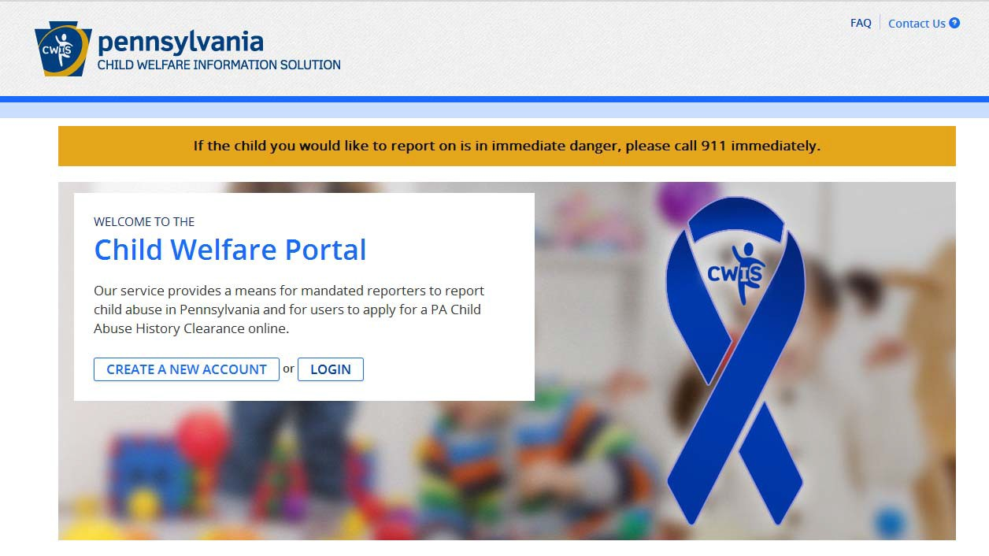
https://www.compass.state.pa.us/cwis/public/home

Click ‘Create a New Account’.

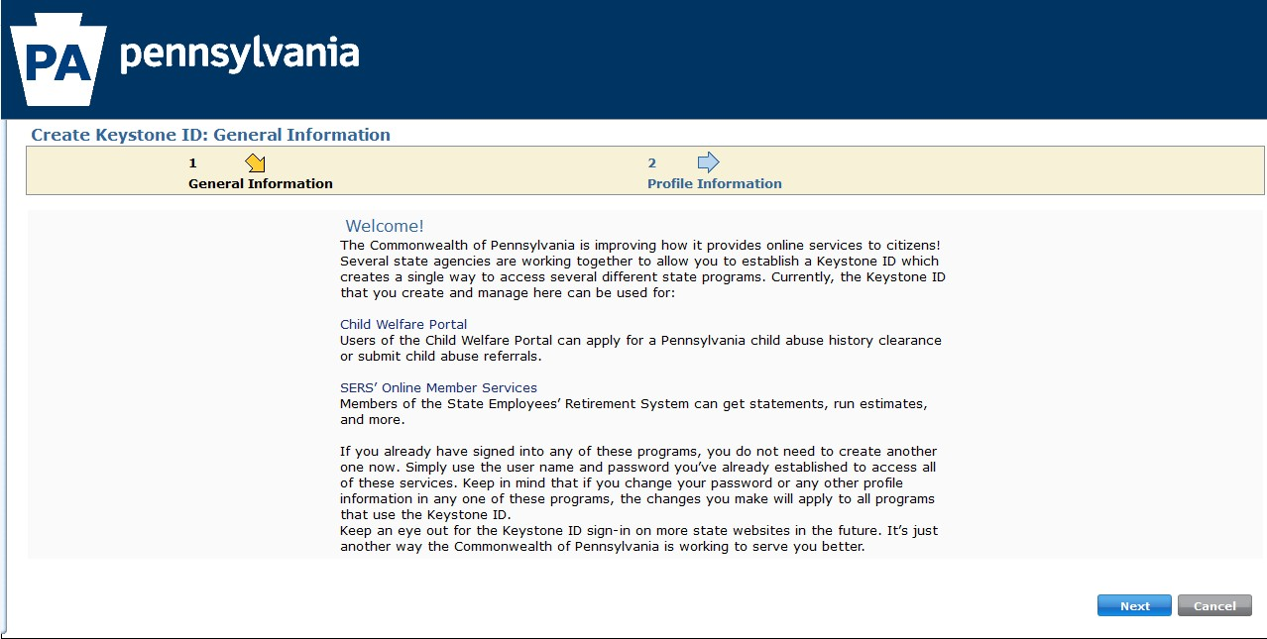
Click ‘Next’ at the bottom right of the page.

CWP Keystone ID Registration

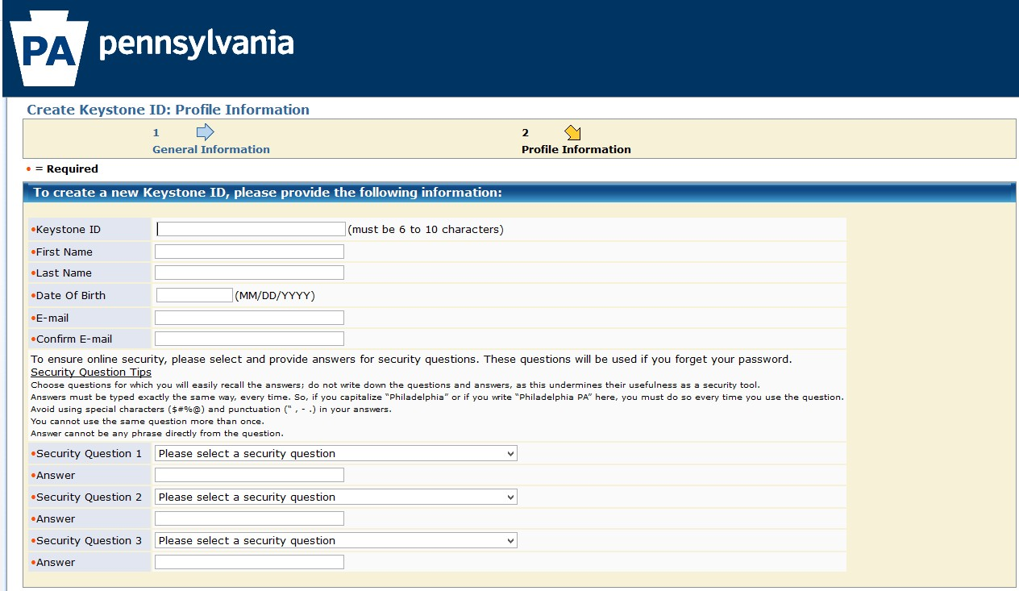

Click ‘Finish’ at the bottom right of the page.

'lJpennsylvania

Check your e-mail for your temporary password!

You have successfully created a KeystoneID and a temporary password has been e-malied to you. For the safety of your personaland financialinformait on,you cannot begin working untilyou retrieve this temporary password and sign back in to the system.You need to use this temporary password the first time you signin. When you sign in for the firsttime, you will be required to create a personalpassword for future use.

Please click the Close Window button andlogni to your application.

Close Window

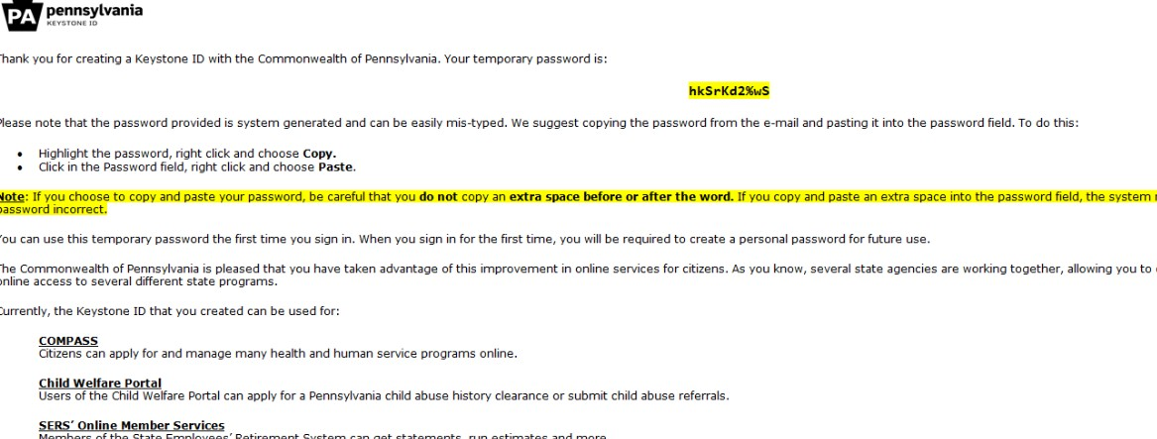

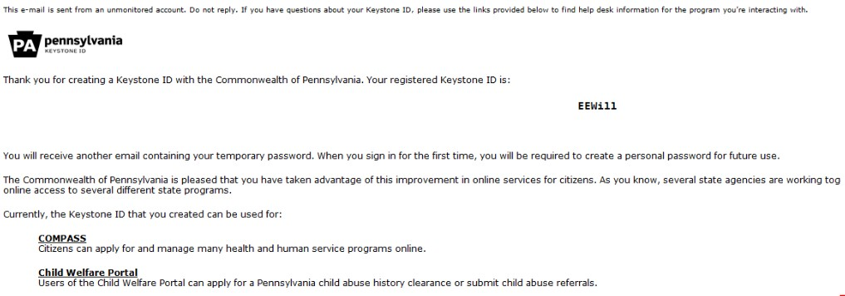
CWP Keystone ID Confirmation emails

Log In ID

Temporary Password

CWP home page
https://www.compass.state.pa.us/cwis/public/home

This time, click ‘LOGIN’.

CWP Keystone ID Log‐in page

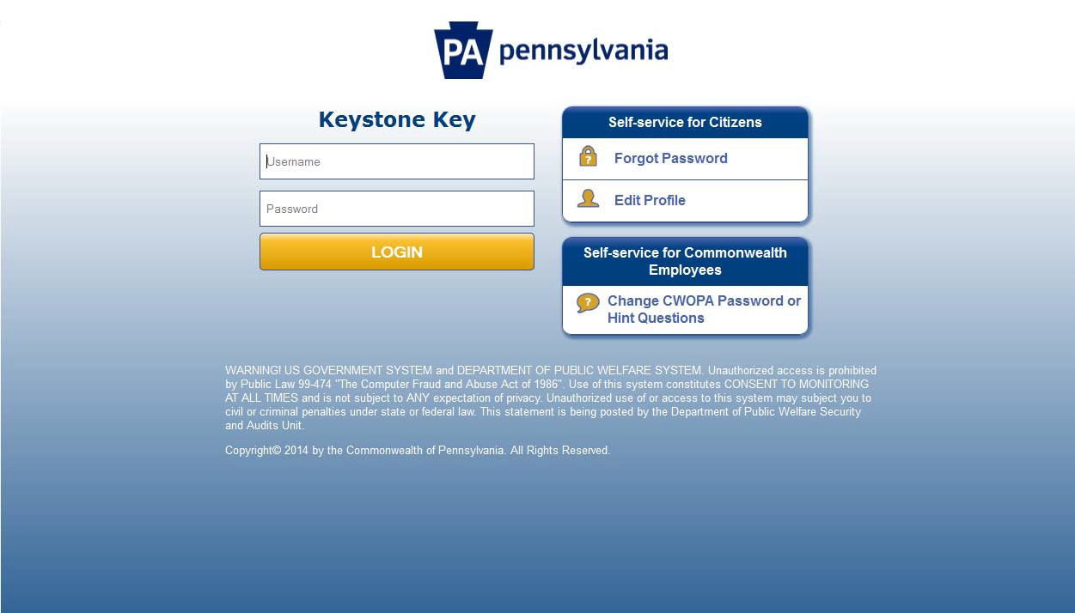

Use Temporary Password sent to your email.

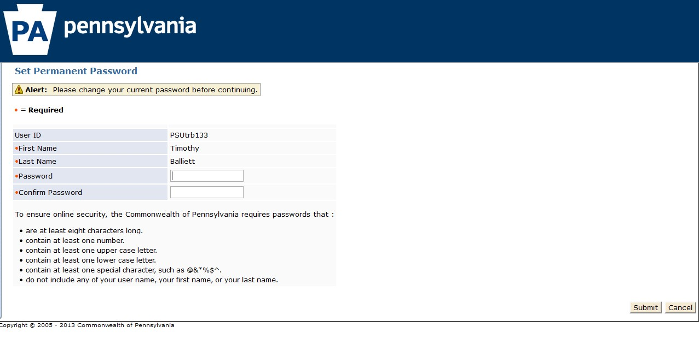
CWP change password page

CWP Password Change Confirmation page

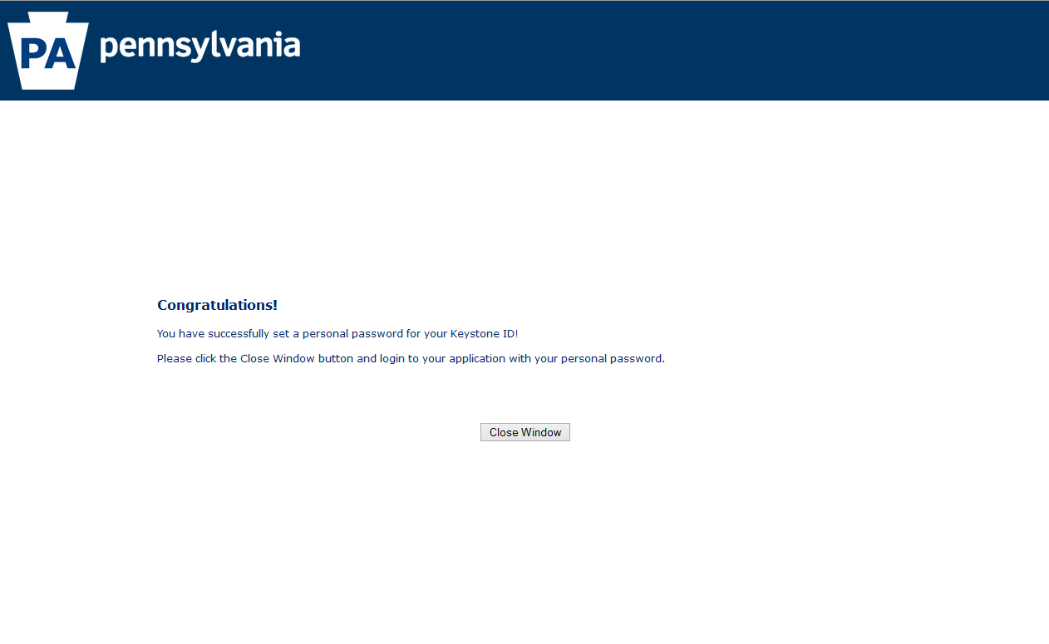

CWP Keystone ID Log‐in page…Again
https://www.compass.state.pa.us/cwis/public/home

Use your new password.

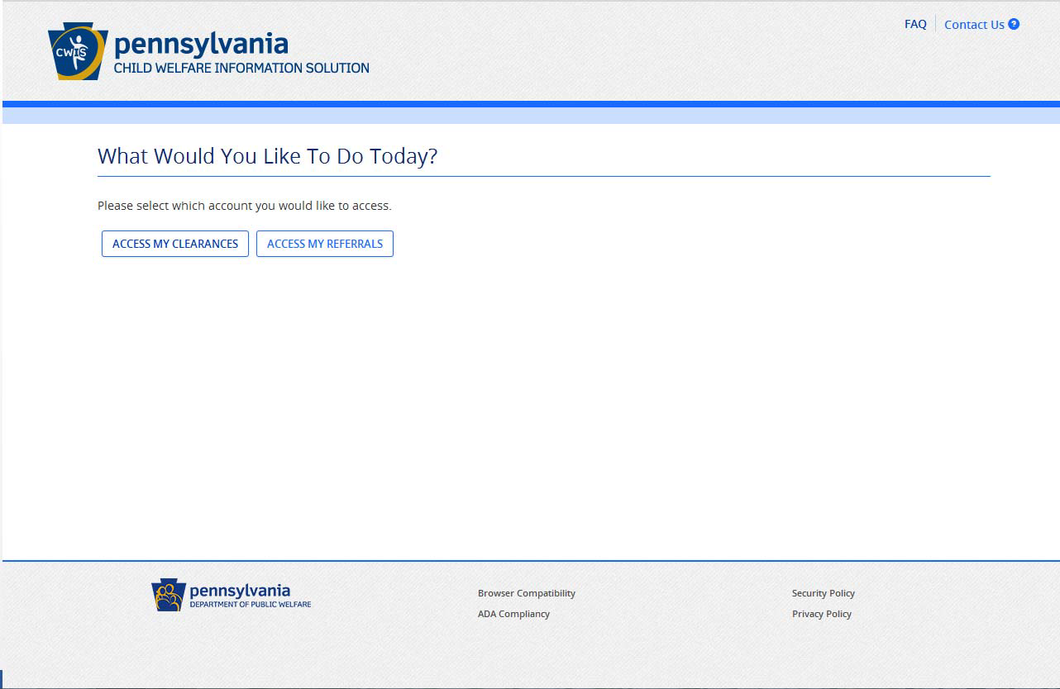
Click on ‘Access My Clearances.’

CWP Information page

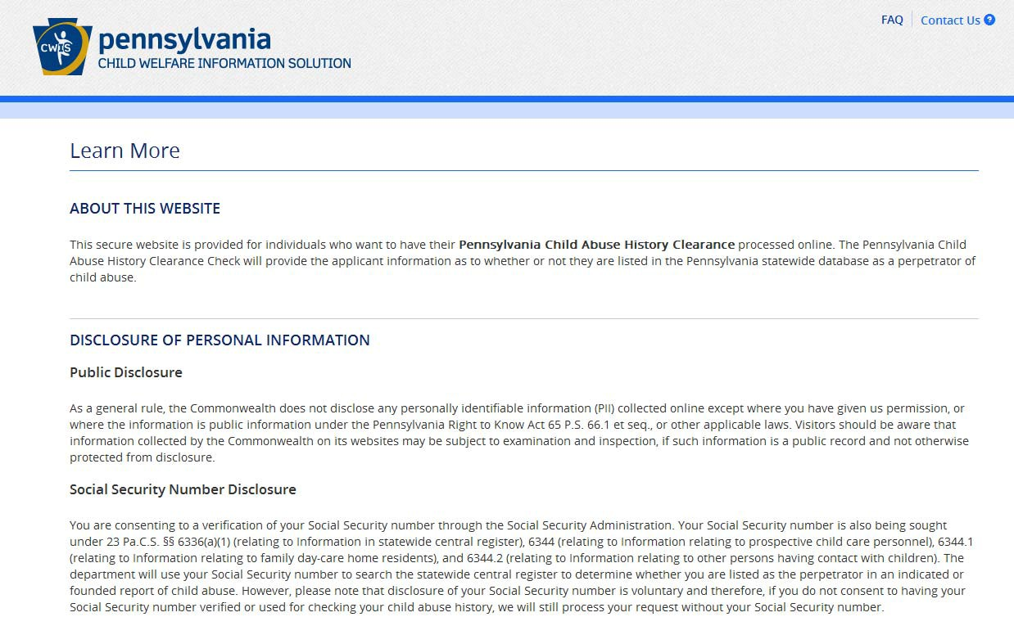

Click ‘Continue’ at the bottom right of the page.

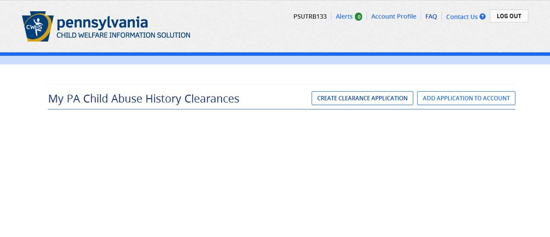
Click ‘Create Clearance Application.’

Submitting a new clearance application

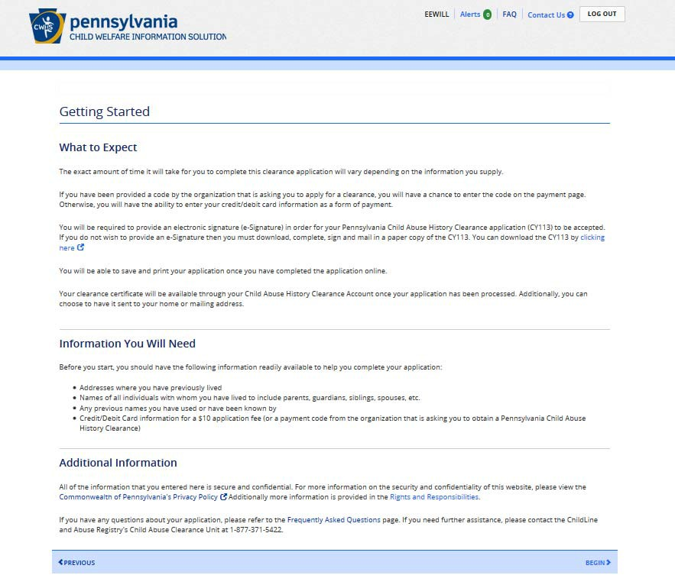
Click ‘Begin’ at the bottom right of the page.

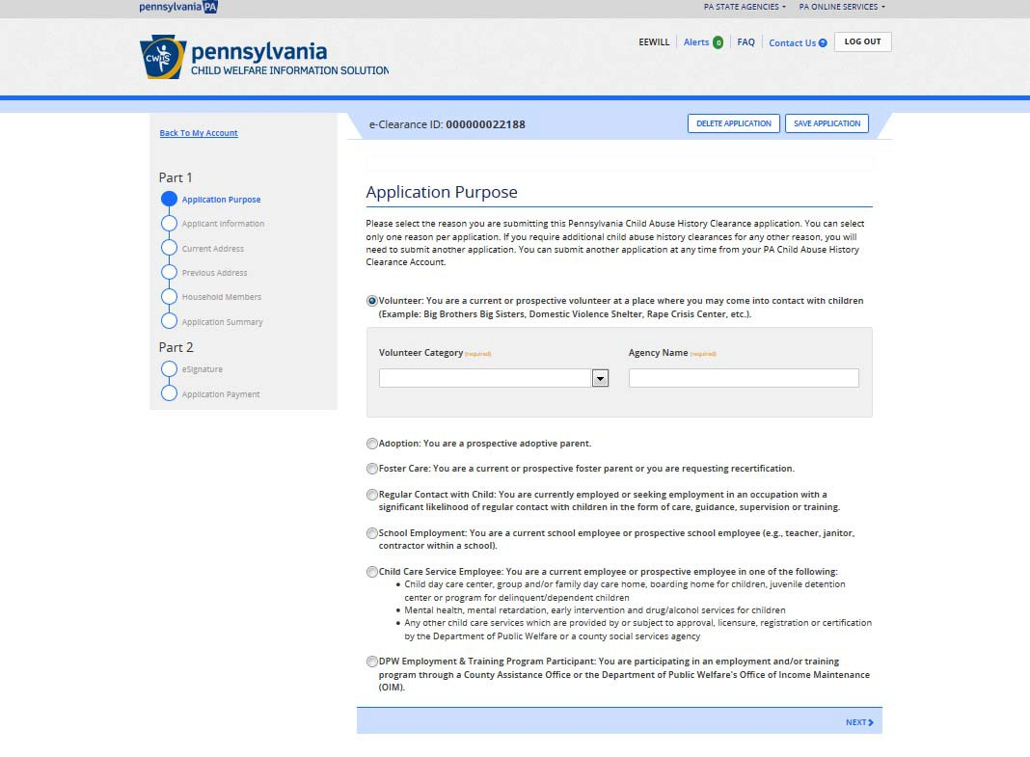

Please select “Other” for
Volunteer Category and enter
Lebanon Valley College
for Agency Name

Select the appropriate category (e.g., Employment with a likelihood of working with children)
and click ‘Next’ at the bottom right of the page.

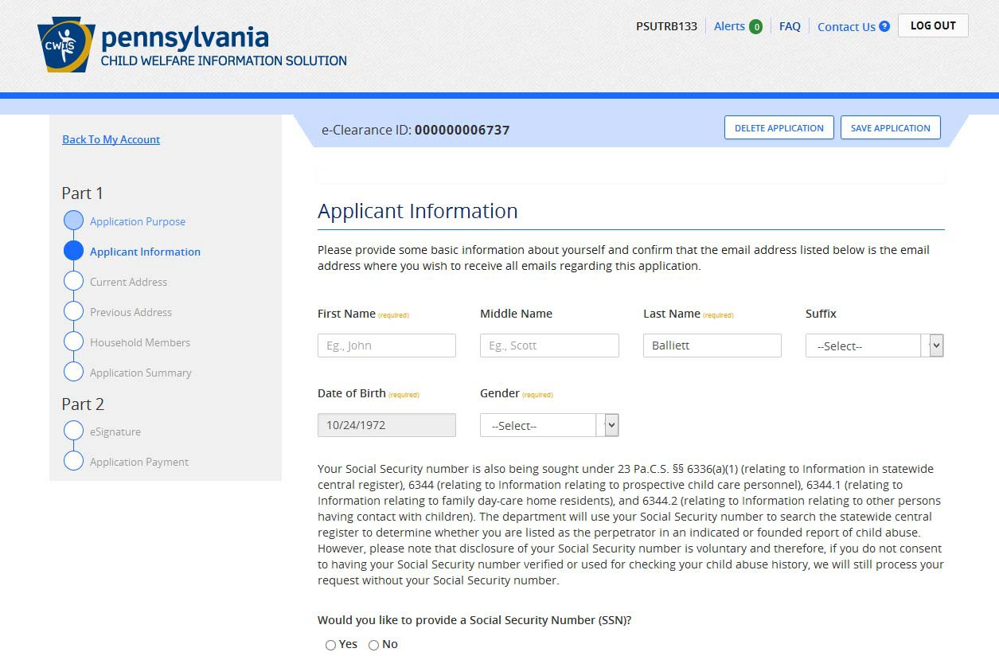

Take note of your e‐Clearance ID.

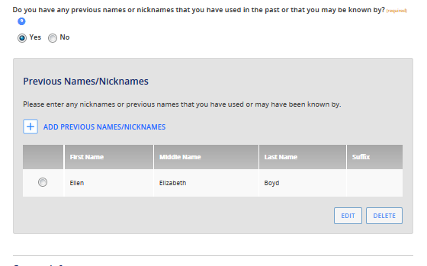

For example, maiden name

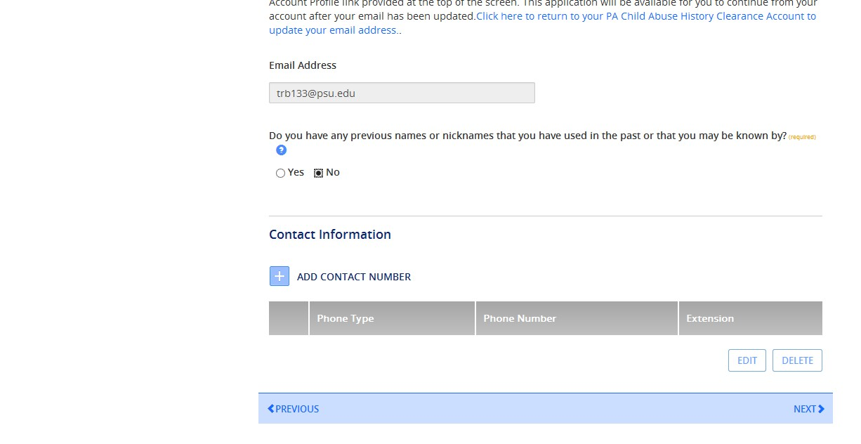

Click ‘Next’ at the bottom of the page.

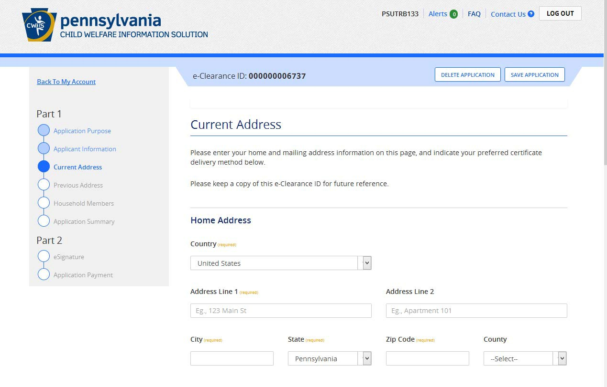

Provide the required information then click ‘Next’ at the bottom of the page.

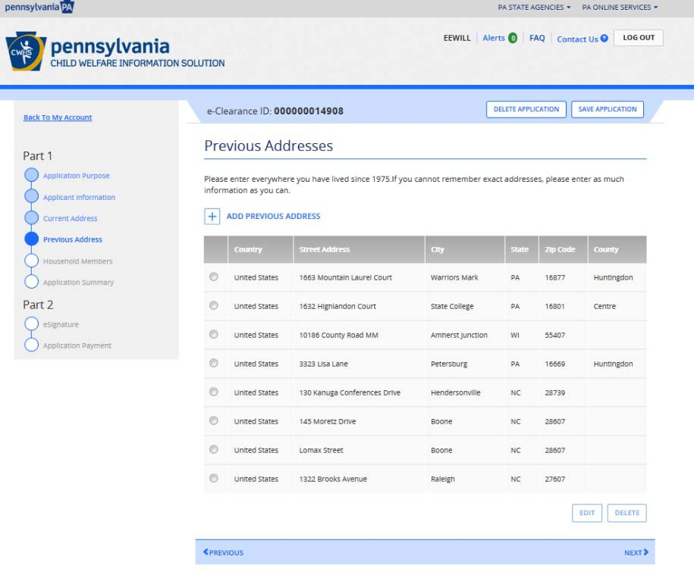

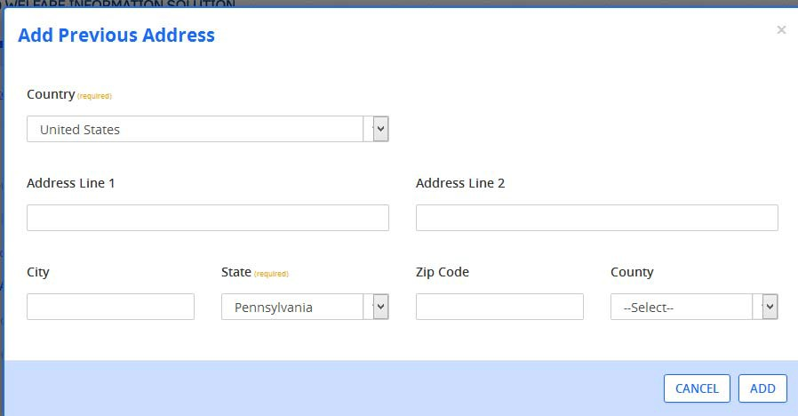

Click ‘Add Previous Address’ as many times as needed, then click ‘Next’ at the bottom of the page.

What if I need to take a break and
finish my application later?
You can save your application!

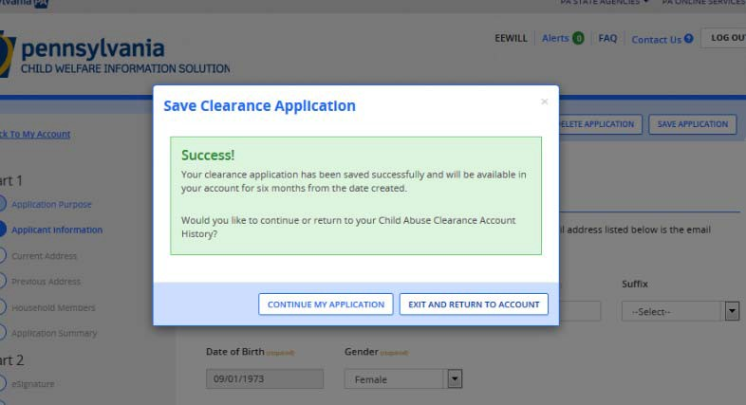
Clicking ‘Save Application’ allows you to return to the portal at a later time to complete it. It’s also just a good idea to save it as you go!

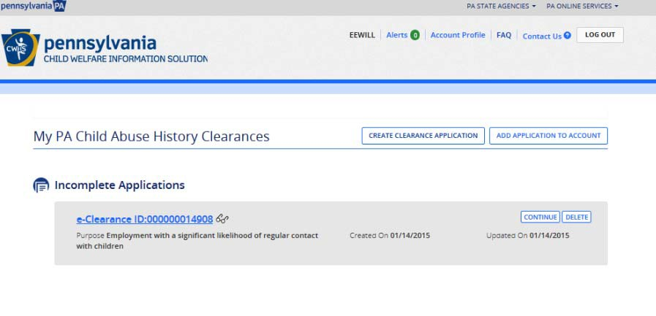

When you log back in to the Portal, click ‘Continue’ to complete your application.

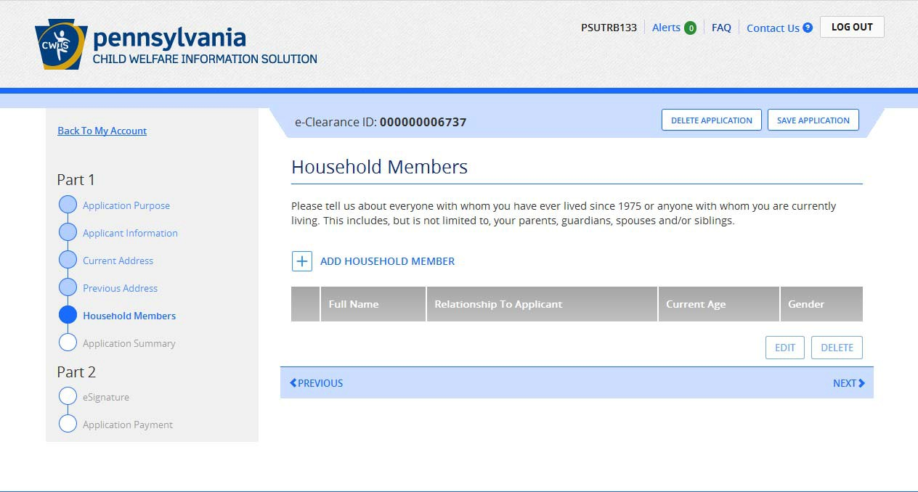

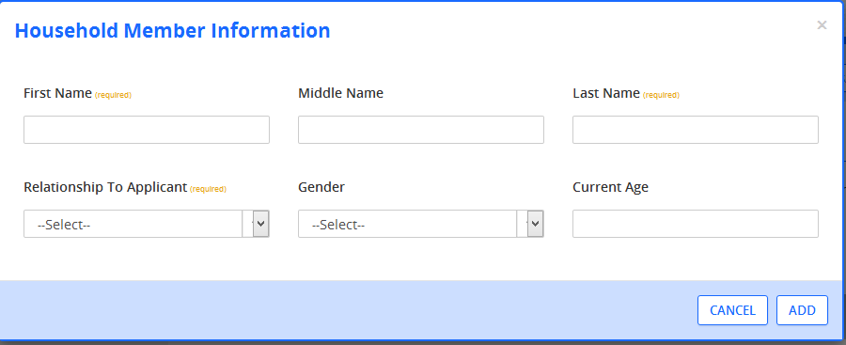

Click ‘Add Household Member’ as many times as needed, then click ‘Next’ at the bottom of the page.

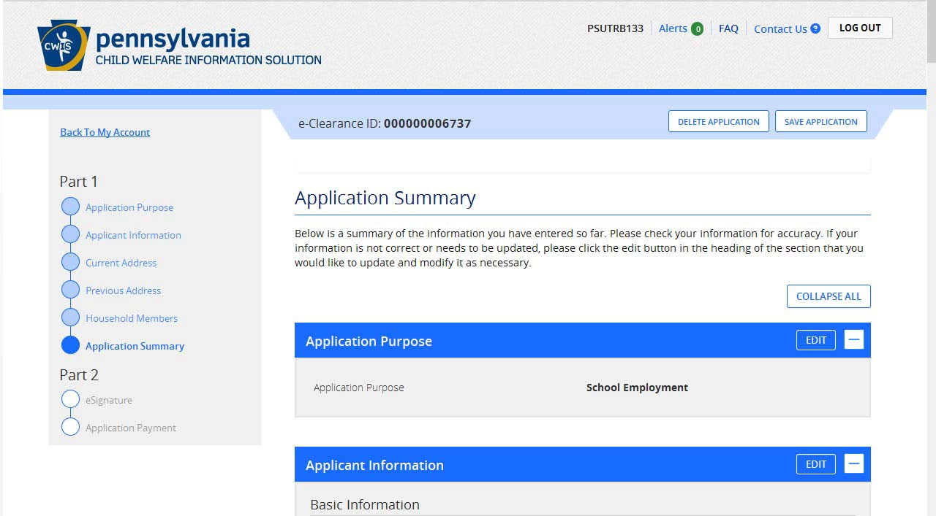

This page is a review of the information you entered. Please check each section for errors. Once you have reviewed everything, click ‘Next’ at the bottom of the page.

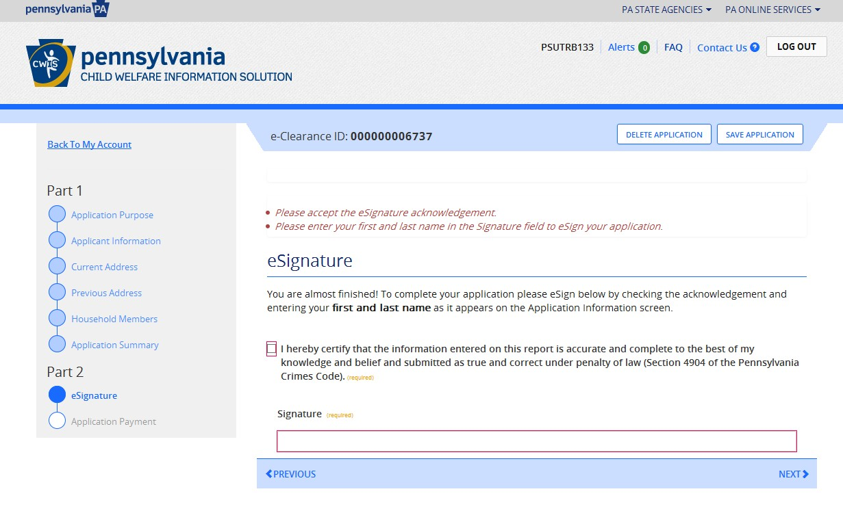

Check the box, enter only your first and last name as it appears on the application, then click ‘Next’ at the bottom of the page.

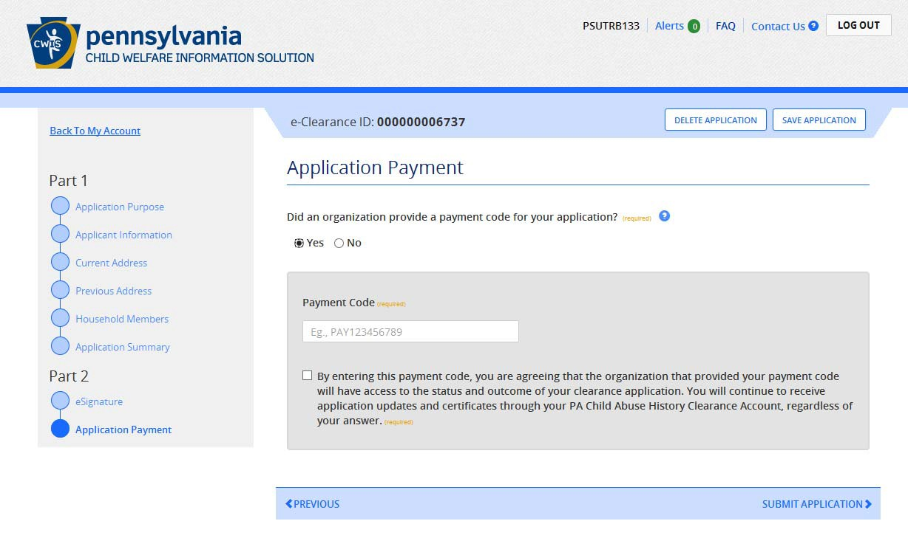

If an organization pre‐paid for your clearance, enter the Payment Code, then click ‘Submit Application’ at the bottom of the page.

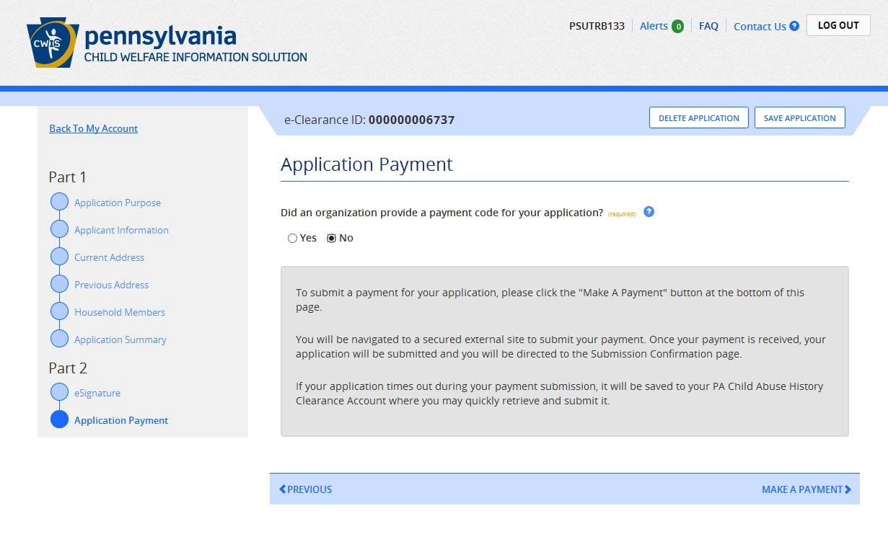

If paying with credit card, then click ‘Make a Payment’ at the bottom of the page.

Payment

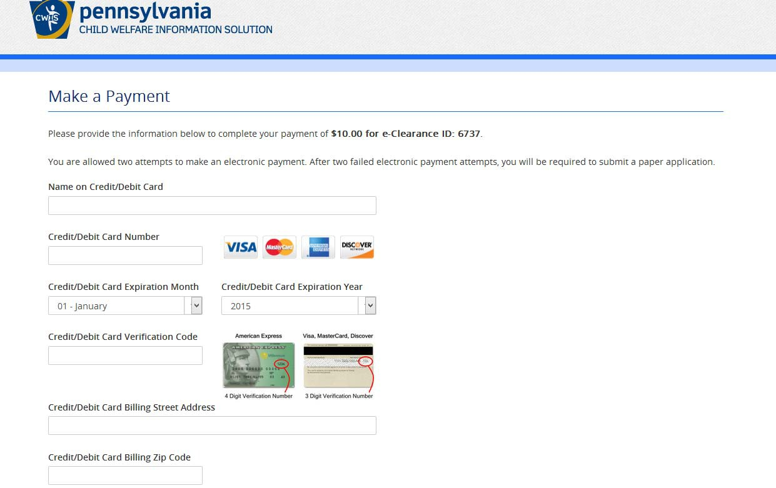

Final Step

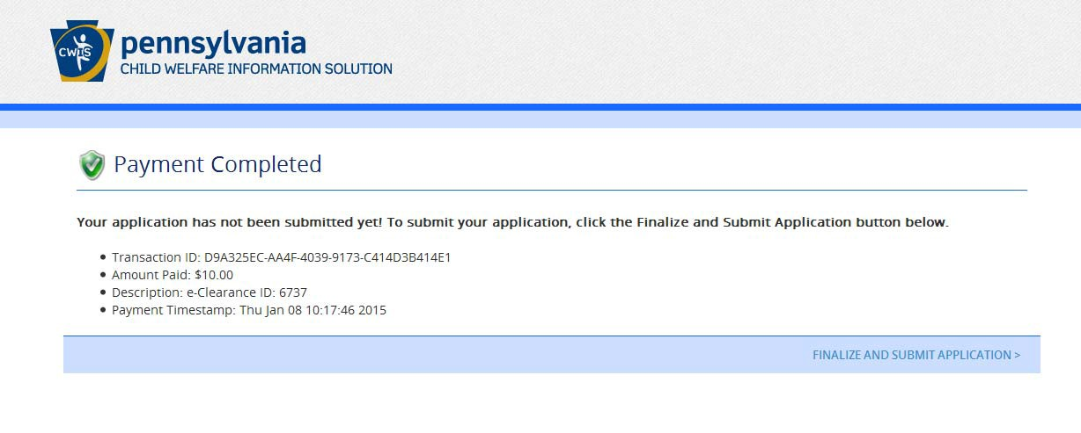
You are not done yet! Click ‘Finalize and Submit Application’ at the bottom of the page.

Application Confirmation

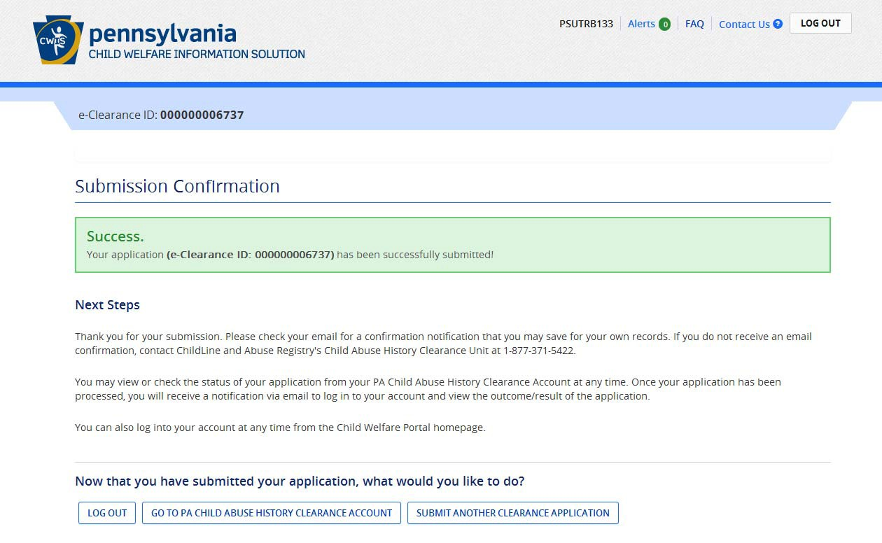

Confirmation E‐Mail

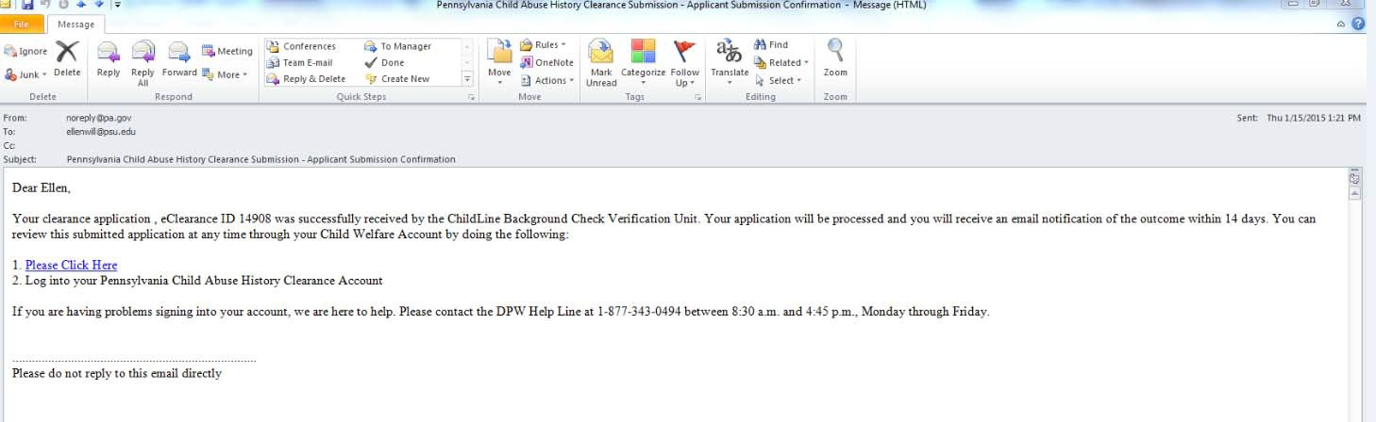

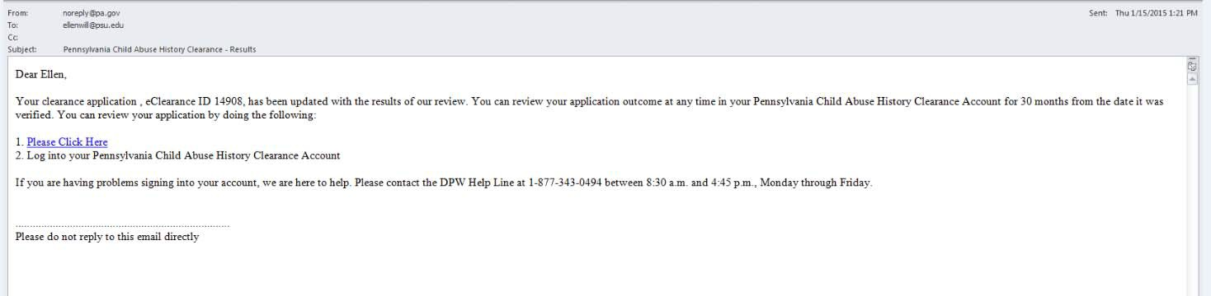

Results Notification

Follow links to the Child Welfare Portal to view your results and print certificate.

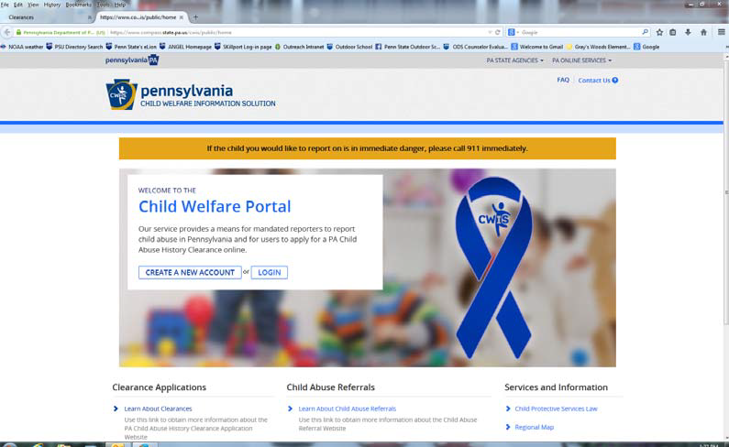
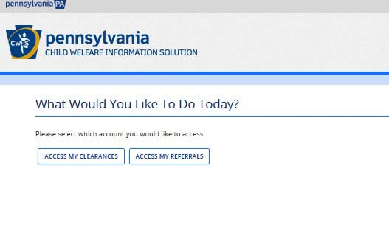
https://www.compass.state.pa.us/cwis/public/home

Click ‘Log In’, then ‘Access My Clearances’

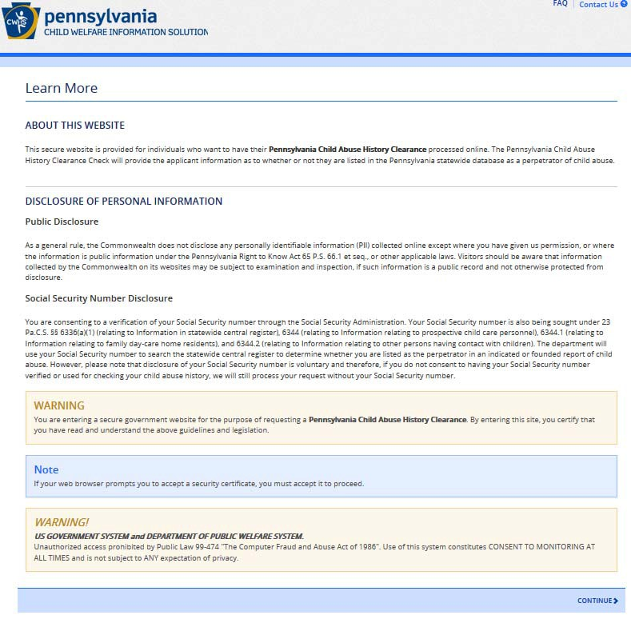

Click ‘Continue’ at the bottom right of the page. .

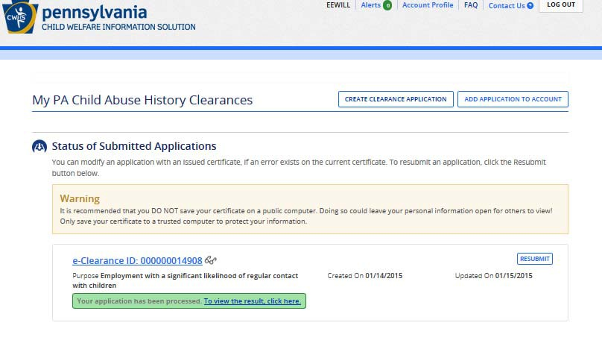
Click the link in the green box to view your clearance.

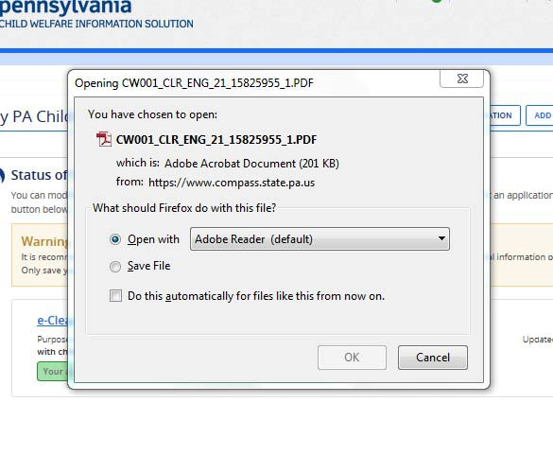

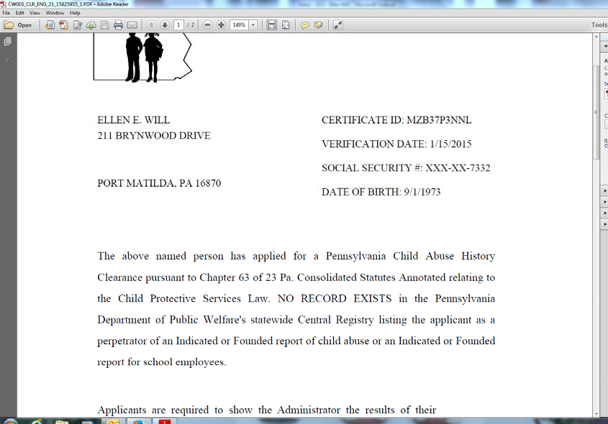
Print and save your clearance!

When you receive the report, upload the PDF document to your Castle Branch Profile. If you do not have a scanner, the original can be scanned in the department.

Pennsylvania Child Welfare Information Solution Portal

https://www.compass.state.pa.us/cwis/public/home

OR

keepkidssafe.pa.gov; click Clearances on the left side, then click the CWIS link

Click the link above to:
Create a Keystone ID Account
Submit a PA Child Abuse Clearance On‐Line
Report Suspected Child Abuse

